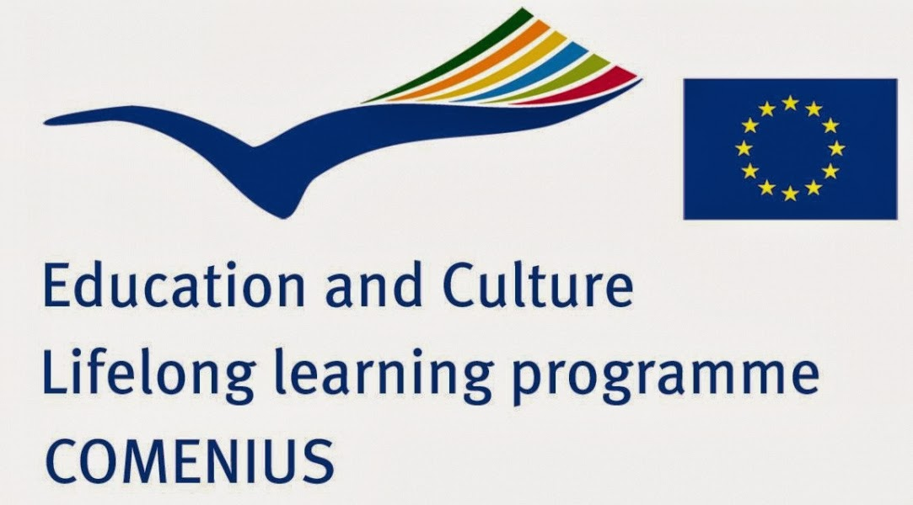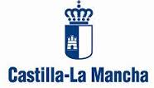
PROGRAMME OF THE 7th MEETING
TOLEDO (SPAIN), 20th April - 24th April 2015
 |  |  |  |  |  | 
LATVIA | PORTUGAL | CZECH REP. | SPAIN | LITHUANIA | GREECE | ROMANIA
SUSTAINABLE DEVELOPMENT – A ‘GREEN’ FUTURE FOR EUROPE
Sunday  19th April |  | Arrivals of the delegations. Accommodation: Hostal Puerta Bisagra www.puertabisagra.com
Monday  20th April | 09:30 | Meeting at the hotel
Monday  20th April | 10:00-12:00 | School Opening Ceremony  Headmaster’s Welcome speech  School tour
Monday  20th April | 12:30-13:30 | Meeting at the City Hall  Meeting with the city councillor for Education and Culture
Monday  20th April | 14:30 – 16:00 | Lunch in the old town. Gambrinus Restaurant (15€)*
Monday  20th April | 16:00-19.00 | Walking tour in the old town  You can visit our web page and have a look the info about tour  http://www.iesmariapacheco.com/  https://www.sites.google.com/site/patrimoniomariapacheco/
Monday  20th April | 19:00 | Free time
Tuesday  21th April | 10.00-13.00 | School International Conference: Sustainable Development a ‘green’ future for Europe  Presentations of the participating countries about Water pollution in their countries (1. Czech Republic 2. Greece 3. Latvia 4. Lithuania 5. Portugal 6. Romania 7. Spain)
Tuesday  21th April | 13:00-14:15 | Spanish popular games
Tuesday  21th April | 14:30-17.00 | Lunch at school (10€)*
 | 17:00 | Free time
Wednesday  22th April | 09.00-16:00 | Riberside walk. Environmental study (pack lunch on the way)
Wednesday  22th April | 16:00-18:30 | Optional Cathedral visit (8€) (students free)
Wednesday  22th April | 18:30-20:00 | Free time
Wednesday  22th April | 20:00-23:00 | Dinner at school (paid by the Spanish school)  Popular songs. Pictures of the previous meetings  Handing over of Certificates
Thursday  23th April | 09.00 – 12:00 | workshop water analysis  writing of the report
Thursday  23th April | 12: 30-13:30 | Meeting at the Education Regional Government
Thursday  23th April | 14:30-16:30 | Lunch in the old town Catavinos Restaurant (15€) *
Thursday  23th April | 16:30-19:30 | Free time
Thursday  23th April | 19:30-21:00 | Dinner in the old town (15€)*
Thursday  23th April | 21:00-22:30 | A night tour around Toledo
Friday  24th April | 10.00-13:00 | Teacher’s meeting  Departure of delegations.

*The students are going to have lunch and dinner with their host families. On Monday they are having lunch with the Spanish students at a burger or pizza restaurant.

